April 7th:

* Solve the question with the test Cases accepted and screenshot it here.
* Explain the code on OBS Studio.
* Figure at least three ways to solve the same question.
* Analyze the runtime complexity of all the three solutions.
* Solve the question in another language, preferably Python.
* Write a brief report on the question, skills learnt e.t.c

[**1. Two Sum**](https://leetcode.com/problems/two-sum/)

Step 1:Solve the question with the test Cases accepted and screenshot it here

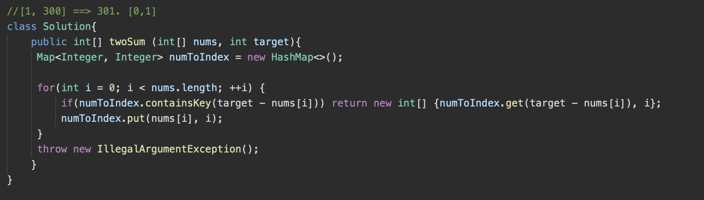

Step 2:Explain the code on OBS Studio.

<https://youtu.be/4UFzvlOq8F8>

Step 3:Figure at least three ways to solve the same question.

TBD

Step 4:Analyze the runtime complexity of all the three solutions.

O(N) for the HashMap Solution - N is the number of elements in the int[ ] nums array. Each element is visited exactly once for the for loop and HashMap operations for an overall complexity of O(n). Linear runtime complexity.

Step 5:Solve the question in another language, preferably Python.

TBD

Step 6:Write a brief report on the question, skills learnt e.t.c

How to .get() and .put() in a hashmap.

Use of containsKey. - looks up the key/index containing the value of interest in the HashMap’s key, value pair arrangement.

Error handling, throw new IllegalArgumentException(“Unrecognized value”);

Using OBS Studio

[4. Median of Two Sorted Arrays](https://leetcode.com/problems/median-of-two-sorted-arrays/)

Step 1: Solve the question with the test Cases accepted and screenshot it here.